**LINQ – Where Clause**

# A picture containing text, computer, software, screenshot Description automatically generatedA screenshot of a computer Description automatically generatedSelect And Select Many

# Order By & Order By Descending

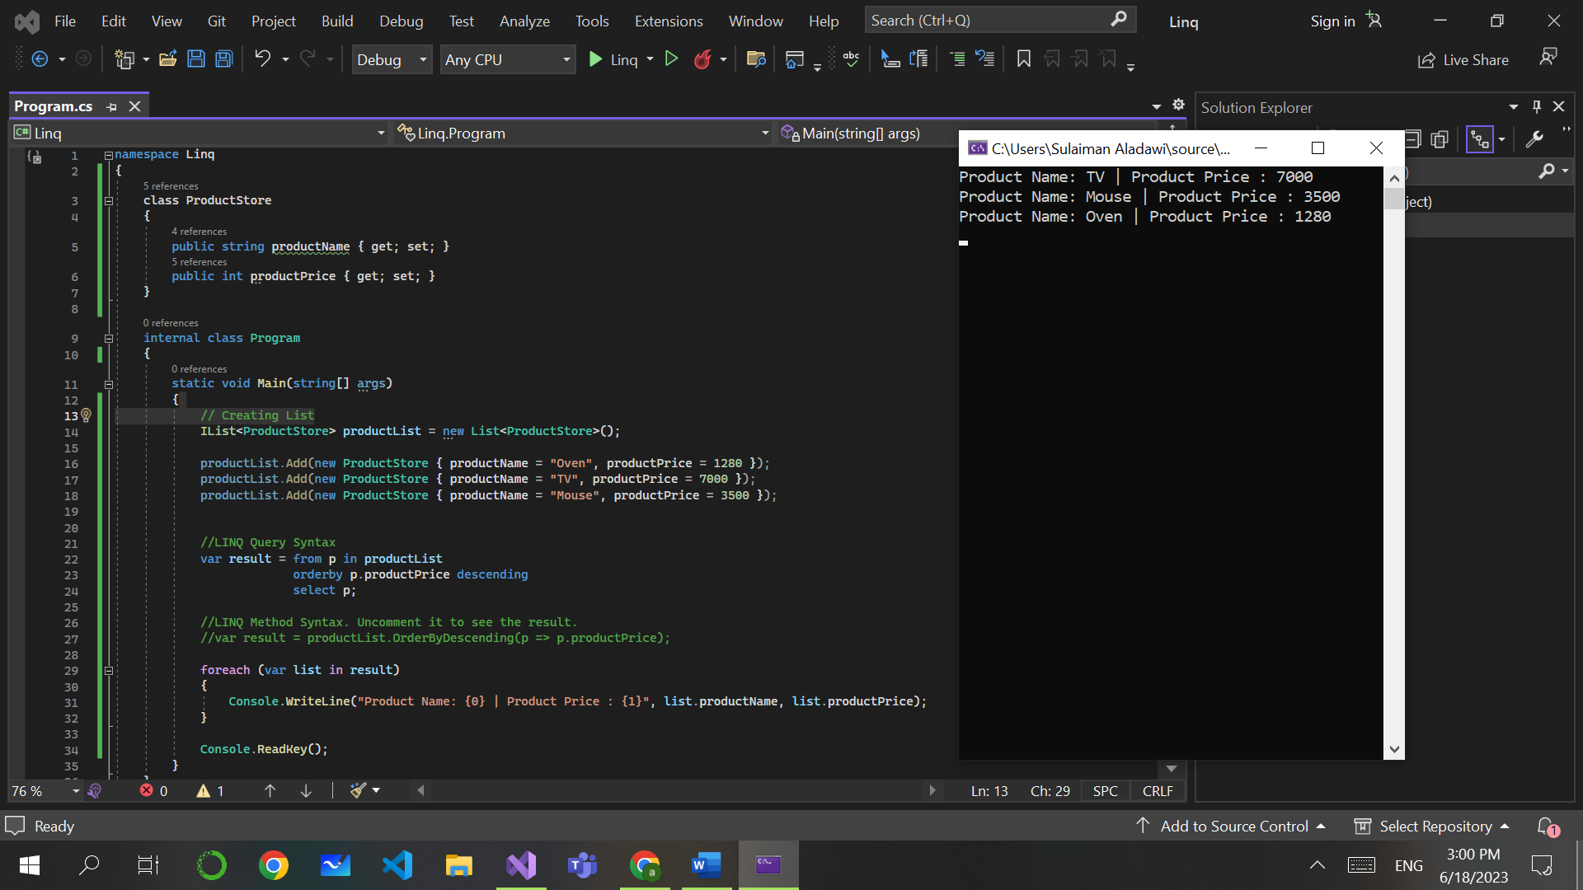

# LINQ (C#) – Then by And Then By Descending

# LINQ C# - Reverse

# LINQ (C#): Group By – Single Key, Multi Key And Grouping With Sorting

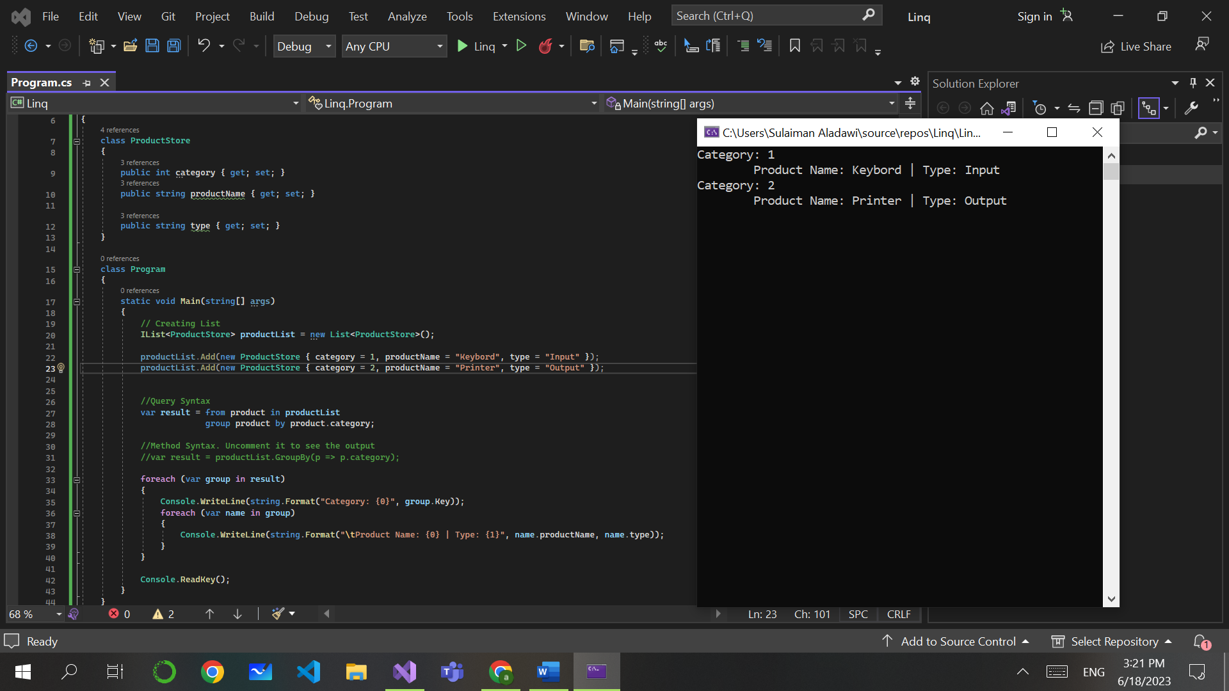

# LINQ (C#) – ToLookup Operator

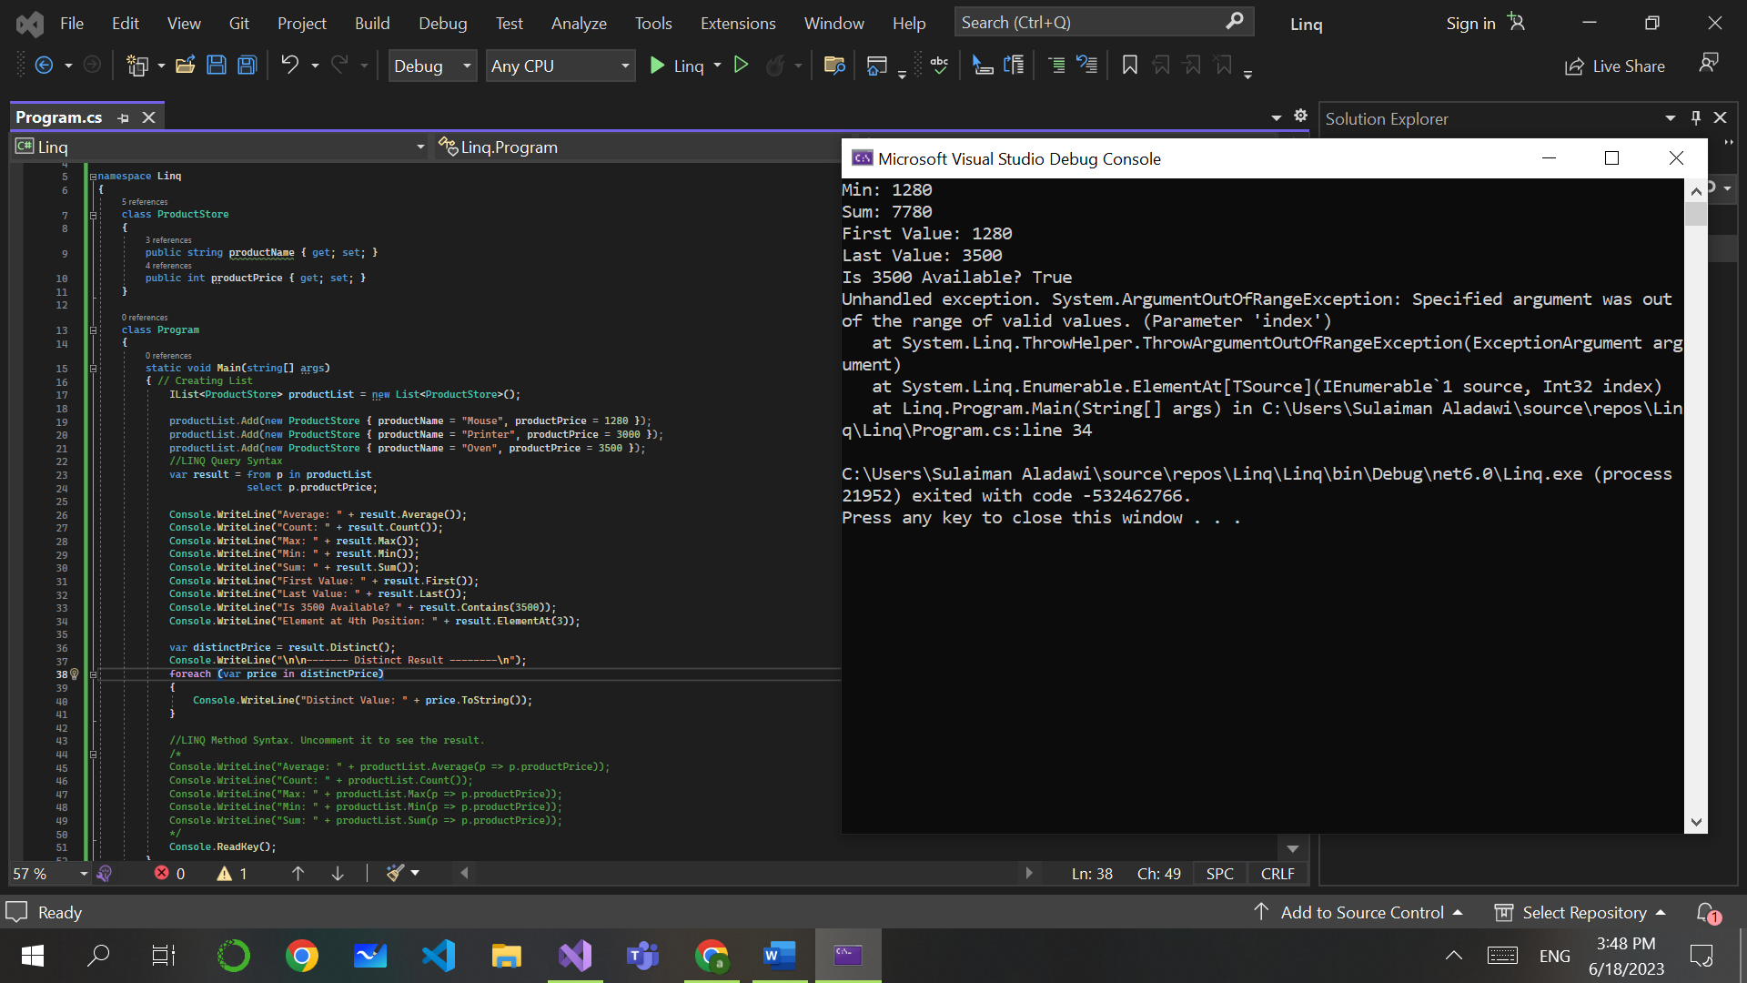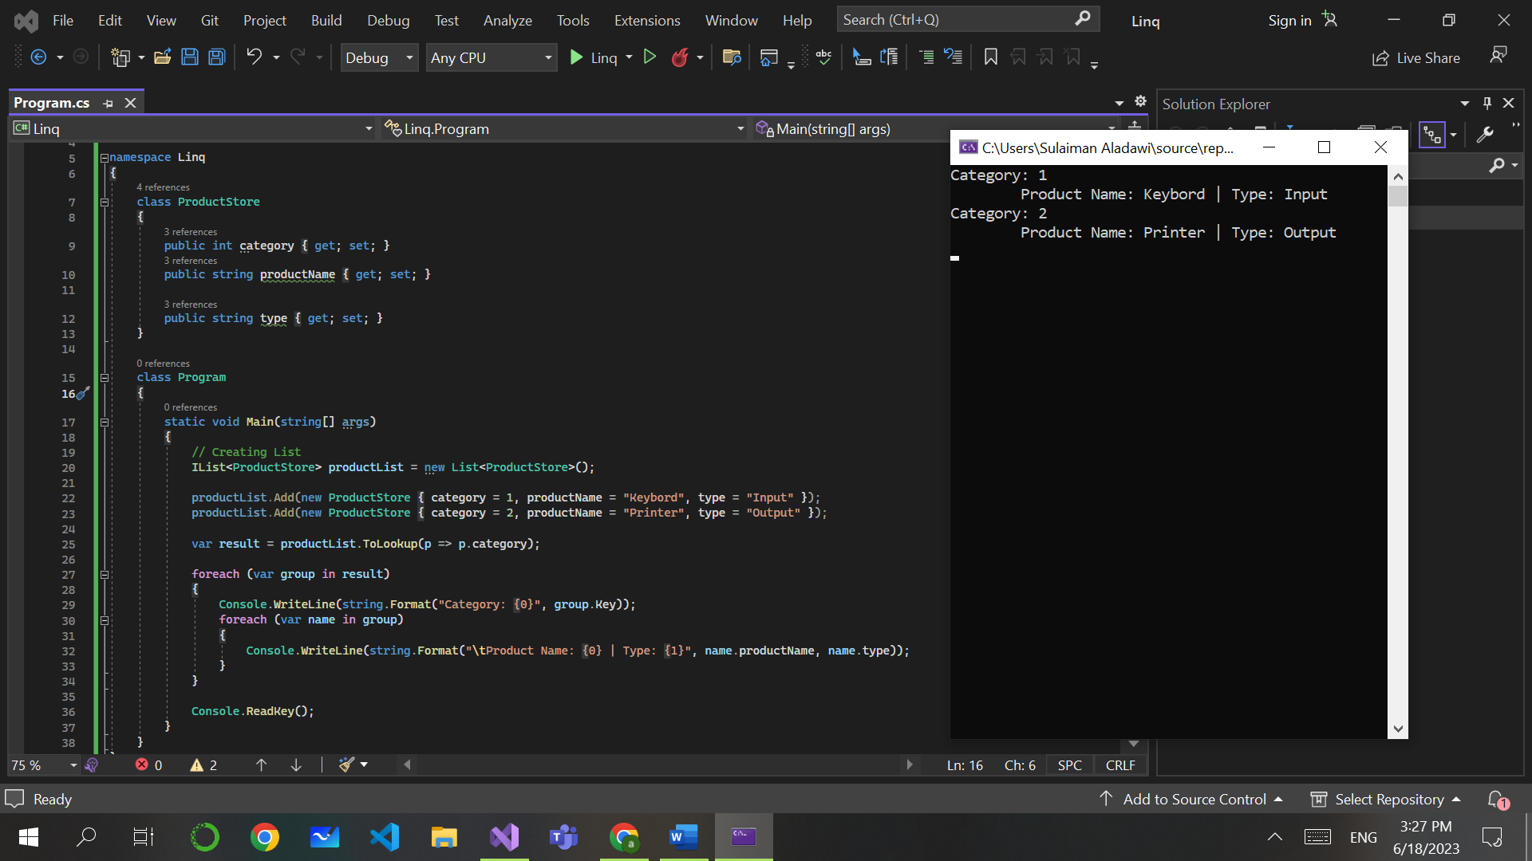

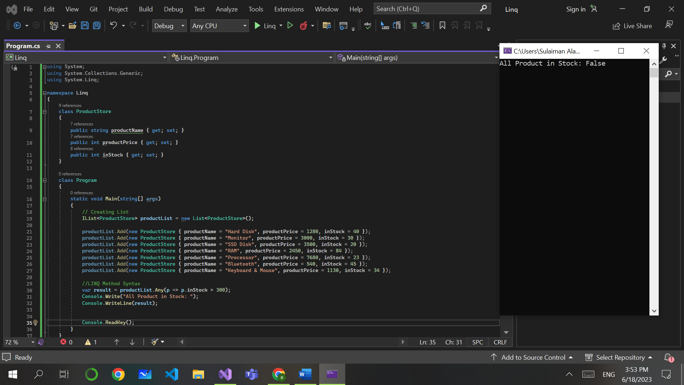  
**LINQ (C#) – All() And Any() Method**

# A picture containing computer, text, screenshot, software Description automatically generatedA picture containing text, computer, screenshot, software Description automatically generatedLINQ (C#) – Range, Repeat and Empty Method

# A picture containing text, software, screenshot, computer Description automatically generatedLINQ With Array and Array List – Search Array Using Lambda Expression